PERFECT TENSES

LEIDY MILENA ACEVEDO MORA

IRMA LUZ VILLA CARDONA
(docente)

INGLES
INSTITUCIÓN EDUCATIVA ALFREDO COCK ARANGO
MEDELLIN-ANTIOQUIA
11-2
2020
ACTIVIDADES DE INICIO
Translate the following sentences:

- Has lived: She has lived here all her life
TRADUCCIÓN: Ella ha vivido aquí toda subida.
INTERROGATIVA: Has she lived here all her life?
NEGATIVA: She has not lived here all her time.

- Have written: They have written three letters already
TRADUCCIÓN: Ellos han escrito tres letras ya.
INTERROGATIVA: Have they written three letters already?
NEGATIVA: They haven’t written three letters a day.

- Have worked: I have worked here since I graduated school
TRADUCCIÓN: Yo he trabajado aquí desde que me gradué.
INTERROGATIVA: Have I worked here since I graduated school?
NEGATIVA: I haven’t worked here since I graduated school

- Has done: He has finished his homework
TRADUCCIÓN: Él ha terminado su tarea.
INTERROGATIVA: Has he finished his homework?
NEGATIVA: He has not finished his homework.

- Have been: We have been to Canada
TRADUCCIÓN: Nosotros hemos estado en Canadá.
INTERROGATIVA: Have we been to Canada?
NEGATIVA: We have not been to Canada.

- Has forgotten: She has forgotten her folder
TRADUCCIÓN: Ella ha olvidado su carpeta.
INTERROGATIVA: Has she forgotten her folder?
NEGATIVA: She has not forgotten her folder.

ACTIVIDADES DE DESARROLLO
Answer the following questions:
- How can you define the past participle?
- The past participle is characterized in spanish with the endings “ADO – IDO” for example, Nadado, Corrido, Saltado. It’s always used with an auxiliary verb. The past participle of the regular verbs in English forms the same than the past of the English adding “ED – D” at the end of the verb.

- What are the structures to the past perfect and future perfect?

- PASADO PERFECTO
SUJETO + HAD + VERBO EN PASADO (REGULAR O IRREGULAR) + COMPLEMENTO

- FUTURO PERFECTO
SUJETO + VERBO AUXILIAR (TO BE) + GOING TO HAVE + PASADO PARTICIPIO

- Write three examples to the past perfect, everyone in affirmative, negative and interrogative form.

- AFFIRMATIVE
- My cousin had gone to Europe to study.
- He had given up the tournament.
- I had forgotten all my problems
- NEGATIVE
- My cousin had not gone to Europe to study.
- He hadn´t given up the tournament.
- I hadn´t forgotten all my problems

- INTERROGATIVE
- Had my cousin gone to Europe to study?
- Had He given up the tournament?
- Had i forgotten all my problems?

4-Write the same examples in future perfect in affirmative, negative and interrogative form.

- AFFIRMATIVE

- My cousin will have gone to europe to study.
- He Will have given up the tournament.
- I Will have forgotten all my problems

- NEGATIVE
- My cousin won't have gone to europe to study
- He won´t have given up the tournament
- I won´t have forgotten all my problems

- INTERROGATIVE
- Will my cousin have gone to europe to study?
- Will he have given up the tournament?
- will i have forgotten all my problems?

ANEXOS

TIMO KEKKONEN
Hi, my name’s Timo Kekkonen. I’m finish and I live in Espoo. I live with my partner, Seija. She’s a receptionist at a hotel. We have a son, matti. He’s two. I work for a bank in Helsinki. I get up very early – at six o’clock, and I leave home at 6:30. I go to work by train. It takes an hour and it’s very crowded. The normal time to start work at my Company is eight o’clock, I get to work at 7:30 because I always have a lot of work. I finish work at 7 o’clock every day. I get home an hour later. It’s a long day, but I don’t work at the weekend.

A TYPICAL DAY | TIMO | YOU
I get up at | Timo gets up at six | I get up at eight
I leave home at | Timo leaves home at six thirty | I leaves home at nine
I get to work at | Timo gets to work at seven thirty | I get to study at ten thirty
I finish work at | Timo finishes work at seven | I finish study at six thirty
I get home at | Timo gets home at eight | I get home at seven

B. Speaking activity

- I get to work at four
- I get up at five thirty
- I finish work at eight 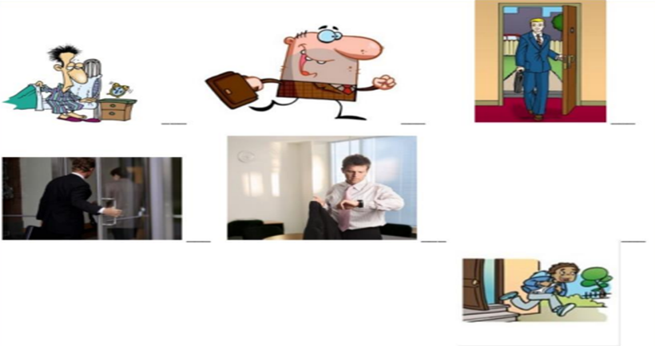
4
6
5
1
3
2
- I go to work by walk
- I leave home at six
- I get home at nine

C. Put he words in the correct order to make the interviewer’s questions.
- you/get up/do/what time/?
- What time do you get up?

- do/leave/you/what time/home/?
- What time do you leave home?

- go/how/you/do/to work/?
- How do you go to work?

- get/what time/to work/you/do/?
- What time do you get to work?

- finish/do/what time/ work/you/?
- What time you do finish work?

- home/what time/you/do/get/?
- What time do you get home?

D.PREPOSITIONS
- I get to work at 7:30 a.m
- We come from Spain
- I work for Air Europe
- They live in London
- We go to work by bus
- I need English for my job
- They finish work at 6:00 p.m

ACTIVITY 4
BUSINESS LANGUAGE
Stephanie Debord
I’m a lawyer in the south of Belgium and my clients work in agriculture. They do business with countries like the UK and the USA. They get a lot of documents in English at work. I sometimes answer the pone, but it’s difficult to understand. I prefer English for emails and letters.

Timo Kekkonen
English is very important in my job. All the information I need is English. My colleagues are in the USA. We speak on the phone and write emails in English. I use English all the time, speaking English is a normal part of my life. I love speaking English and working with people from other countries. It’s great. But when I write emails in English I make a lot of spelling mistakes. It’s really tricky.

-Circle the correct answer:

A. Stephanie Debord needs English to…
1-visit her relatives in the UK
2-learn some of her favorite récipes
3-communicate with her husband
4-read and explain the documents for her clients in Belgium

B. Timo kekkonen needs English for…
1-sing karaoke every time he can
2-write and speak with his colleagues in the USA
3-read the local newspaper every day
4-fill in some customer satisfaction surveys
C. TRUE OR FALSE
T= TRUE
F=FALSE

1-Stephanie is a lawyer (T)
2-Her clients don’t work in agriculture (F)
3-Her clients do business with countries like UK and USA (T)
4-She writes and explains the documents for ther clients (T)
5-She speaks English in her office all the time (F)
6-In her opinion, it’s easy to understand English when she answers the phone (F)
7-Timo doesn’t make spelling mistakes when writing emails (F)
8-His colleagues are in New York and Los Angeles (T)
9-He dislikes English (F)
10-Timo speaks Spanish with his colleagues all the time (F)

